

MASENO UNIVERSITY

**SCHOOL OF COMPUTING AND INFORMATICS**

**DEPARTMENT OF INFOR MATION TECHNOLOGY**

**PROJECT: WEB-BASED SCIENCE LABORATORY SYSTEM**

**PROJECT PROPOSAL SUBMITTED TO THE SCHOOL OF COMPUTING AND INFORMATICS IN PARTIAL FULFILMENT OF THE REQUIREMENTS FOR AWARD OF THE DEGREE OF BACHELOR OF SCIENCE IN INFORMATION TECHNOLOGY**

**JUNE, 2017**



# DECLARATION

We hereby testify that everything in this documentation is our original work and has not been presented in this institution or anywhere else. We know that our project shall not be accepted with undeclared sources and that plagiarism is not allowed...

KILAMBO CHARLES

CI/00064/014

SIGN………………………………. DATE…………………………………..

NJUGUNA MARY

CI/00081/014

SIGN……………………………… DATE……………………………………

KIMANI KEVIN

CI/00082/014

SIGN……………………………... DATE………………………………….



**Declaration by the Supervisor**

This proposal has been submitted for examination with my approval as the appointed University supervisor.

**NAME**: MR. JAMES CHAMWAMA

**SIGN**………………….. **DATE**:……………………...

# 

simulated oratory.

# 

Almighty whothroughout

Table of Contents

DECLARATION i

ABSTRACT ii

ACKNOWLEDGEMENT iii

LIST OF FIGURES vii

CHAPTER 1: INTRODUCTION 1

1.1 BACKGROUND 1

1.2 PROBLEM STATEMENT 1

1.3 OBJECTIVES 2

1.4 SCOPE 2

1.5 JUSTIFICATION 2

CHAPTER 2: LITERATURE REVIEW 3

2.1 INTORDUCTION. 3

2.2.1 PACKET TRACER 5

2.2.2 ONLINE LABORATORY SYSTEMS 5

2.2.3 WEB-BASED SCIENCE LABORATORY SYSTEM EXPECTATIONS. 6

3.1 INTRODUCTION 7

3.2 PLANNING 7

3.2.1 Observations 8

3.2.2 Interviews 8

3.2.3 Questionnaires 8

3.2.4 Forms/ documents examination 8

CHAPTER 4: SYSTEMs ANALYSIS 9

4.1 FEASIBILITY STUDY 9

4.2 REQUIREMENTS ANALYSIS 10

4.2.1. System Stake holders 10

4.2.2. User requirements 10

4.2.3. Functional requirements 10

4.2.4. Non-functional requirements 10

CHAPTER 5: SYSTEMS DESIGN 12

5.1 USE CASE DIAGRAM 12

5.3 ENTITY RELATION DIAGRAM 14

5.4 DATA FLOW DIAGRAM 15

5.5 DATABASE DESIGN 16

CHAPTER 6:SYSTEM IMPLEMENTATION AND TESTING. 19

CHAPTER 7: CONCLUSION 21

USER MANUAL 23

APPENDIX B 30

BIBLIOGRAPHY 31

# LIST OF FIGURES

Figure 2 USE CASE DIAGRAM 12

Figure 3 CLASS DIAGRAM 13

Figure 4 ENTITY RELATION DIAGRAM 14

Figure 5 DATA FLOW DIAGRAM 15

Figure 6 INPUT DESIGN 17

Figure 7 OUTPUT DESIGNAPPENDIX 18

Figure 8 homepage 23

Figure 9 user registration 24

Figure 10 user login 25

Figure 11 contacts 26

Figure 12 simulations 27

Figure 13 sample balancing chemical equation simulation 28

# CHAPTER 1: INTRODUCTION

# 1.1 BACKGROUND

A number of science subjects taught require practical teaching and demonstrations especially in secondary schools and universities. In attempt to avail facilities for practical subjects in schools there have been several challenges experienced. The challenges include having poorly equipped laboratories in our schools which has limited number of experiments that can be performed. This has also limited the number of students who can be able to participate in those experiments and lead to low interest in practical subjects especially schools where the number of students is very high. Finally in most of our schools students are not allowed to access laboratory equipment due to breakage and misuse of chemicals and some causing accidents.

Due to the above shortcomings we saw it necessary to come up with a system that ensures most of the activities that are done manual can be integrated laboratory based system that provides most practical’s at mouse click thus increased efficiency and availability.

## 1.2 PROBLEM STATEMENT

The proposed project aims to solve most problems that are in our school labs. The specific problems addressed are:

1. Most learning institutions in Kenya have limited access to laboratory equipment, and the few that have, the equipment and laboratories are poorly maintained.
2. There is apathy among learners in Kenyan academic institutions in undertaking laboratory experiments, due to the poor state of equipment and the resultant general lack of motivation to undertake science based courses.
3. Presently, local schools do not have custom simulation software suitable for conducting and running simulated laboratory experiments in relevant subject areas.
4. Some experiments in the laboratory are very dangerous thus can result to harm on students upon poor handling

## 1.3 OBJECTIVES

The aim of the proposed system is to address the shortcomings that arise during scientific experiment due to poor laboratories in most of our schools. It aims:

1. To design a system that allows ease of access to laboratory virtual equipment and experiments which require no special handling or maintenance?
2. nd develop ay prototype
3. To provide a realistic, standardized learning opportunity for students without the risks and limitations associated with actual hands-on experiment.

## 1.4 SCOPE

The proposed project focuses on institution laboratories. It will concentrate on the possible computerization of a supplemental virtual science laboratory that will run side by side with the physical science laboratories to facilitate covering of all practical’s fully. The information system will contain procedure documentation, recordings, animated simulation, and assessment questions.

## 1.5 JUSTIFICATION

Upon successfully completion of this project it can be adapted in high schools across the country to provide students access of information on laboratory experiment and practical. The proposed system will ensure that difficulty in acquisition of lab instrument and chemicals does not affect students learning.

# CHAPTER 2: LITERATURE REVIEW

## 2.1 INTORDUCTION.

Due to advancement in technology, we now live in an era characterized by the rapid development of technology. Computer technology has now invaded the education process and is providing us with many opportunities to exploit. There have been needs for integrated scientific learning that promotes the development of methodological skills and competencies, teamwork and communication among students through collaborative activities. This has expanded on traditional lessons and motivated students to actively participate in science and has been used to change education pattern in Kenya.

One of the technologies that have been used is virtual laboratories. In fact many European schools are equipped with computer classes, tablets and high speed Internet connection while a huge variety of web-based learning applications, simulation and visualization unlike in Kenya which is still a developing country and should now start implementing such technologies.

A virtual laboratory can be defined as an environment in which experiments are conducted or controlled partly or wholly through computer operation, simulation, and or animation either locally or remotely via the Internet.

Laboratory-based courses play a critical role in scientific education. Automation is changing the nature of these laboratories, and there has been a long-running debate about the value of hands-on versus simulated laboratories. In addition, the introduction of remote laboratories adds a third category to the debate.

**DIFFERENT TYPES OF LABORATORIES.**

1. Hand-on Laboratory – The actor uses the equipment with his or her hands getting direct feedback to any actions performed
2. Distance Laboratory – It’s a web platform offering any kind of online accessibility experiment. They can be remote or virtual and simulated.

* Remote Laboratory – an online lab that allows actors to carry out experiments over the internet which are normally performed in real-time physical studies in educational laboratories.
* Virtual/simulated – Is an integration of virtual labs into a lab management system is generally easier than integrating remote hardware based labs. It consists of a specific piece of software which may be proprietary or web service that is simulated or visualized in the software.

Through a review of the literature related to these labs in education, several conclusions about the state of current research have been made. The debate over different technologies is confounded by the use of different educational objectives as criteria for judging the laboratories: Hands-on advocates emphasize design skills, while remote lab advocates focus on conceptual understanding. We observe that the boundaries among the three labs are blurred in the sense that most laboratories are mediated by computers, and that the psychology of presence may be as important as technology.

Lab-based courses play an important role in scientific education.

“ (Nersessian, Conceptual change in science and science education, 1991)goes so far as to claim that hands-on experience is at the heart of science learning and is also declared that laboratory experiences “make science come alive (Clough, 2002)). Lab courses have a strong impact on students’ learning outcomes, (magin, 1986).

Researchers have convincingly argued that information technology has dramatically changed the laboratory education landscape (Scanlon, 2002).

As a background for the technologies there is a set of economic issues. Schools are struggling with the very heavy financial burden of maintenance of the expensive apparatus in the traditional laboratories and also seek for reduced expenses. However people have argued that students may be deprived of hands-on experiences they need in order to become the scientists they need to become.

**2.2 EXISTING VIRTUAL LABS SYSTEMS.**

### 2.2.1 PACKET TRACER

Cisco Packet Tracer is a powerful network simulation program that allows students to experiment with network behavior and answer many questions that can only be done in a practical environment. As an integral part of the Networking Academy comprehensive learning experience, Packet Tracer provides simulation, visualization, authoring, assessment, and collaboration capabilities and facilitates the teaching and learning of complex technology concepts using the virtual laboratory.

Packet Tracer supplements physical equipment in the classroom by allowing students to create a network with an almost unlimited number of devices, encouraging practice, discovery, and troubleshooting. The simulation-based learning environment helps students develop 21st century skills such as decision making, creative and critical thinking, and problem solving. Packet Tracer complements the Networking Academy curricula, allowing instructors to easily teach and demonstrate complex technical concepts and networking systems design.

### 2.2.2 ONLINE LABORATORY SYSTEMS

Online Labs is based on the idea that lab experiments can be taught using the Internet, more efficiently. The labs can also be made available to students with no access to physical labs or where equipment is not available owing to being scarce or costly. This helps them compete with students in better equipped schools and bridges the digital divide and geographical distances. The experiments can be accessed anytime and anywhere, overcoming the constraints on time felt when having access to the physical lab for only a short period of time.

The development of online labs includes the study and use of mathematical techniques to demonstrate the various complex functions in diverse areas of science. The labs make use of cutting edge simulation technology to create real world lab environments. Thorough study and research is done by research personnel for better understanding of the experimental procedures. Real lab scenarios are captured through live demonstration of the experiment so as to assimilate information on the procedures and lab equipment. Visualization and development of the graphical symbols are done based on realistic situations and compared with the respective real equipment. Simulations are made interactive using various authoring tools, thus recreating and simulating a real lab environment.

The features include;

* Content aligned to institutions Syllabus.
* Physics, Chemistry, Biology Labs for all levels.
* Interactive simulations, animations and lab videos.
* The concepts and understanding of the experiment.
* The ability to perform, record and learn experiments - anywhere, anytime, and individualized practice in all areas of experimentation.

### 2.2.3 WEB-BASED SCIENCE LABORATORY SYSTEM EXPECTATIONS.

The proposed web based laboratory system is aiming to see a number of limitations in our learning institution catered for by reducing the amount of resources that are used in experiments that is; purchasing and maintaining equipment and cost incurred when paying laboratory technicians.

It will also provide different practical for practical subjects.

**CHAPTER THREE: METHODOLOGY**

## 3.1 INTRODUCTION

The lab system employed the system development life cycle (SDLC) for its development process.

The system development life cycle is going through different stages as shown below:

## 

Figure SDLC

PLANNING

ANALYSIS

MAINTAINANCE

DESIGN

IMPLEMENTATION

TESTING

DEVELOPMENT

## 3.2 PLANNING

Here the new laboratory system of operations applicability were viewed from different institutions by the challenges they experience using the traditional system of operations.

Feasibility tests shall be introduced to confirm if the proposed system is justified for our institutions.

The various techniques used to collect relevant information included the following:

# 3.2.1 Observations

In order to see and learn how most of the schools a carry out the experiments various schools were observed and saw how various laboratory practical are carried out. This helped realize how many institutions have had fault in conducting their laboratory practical due to various unlimited factors.

# 3.2.2 Interviews

In order to get personal views from different people different students and their tutors answered several questions concerning the current systems of operations in order to determine where best the system will fit.

A sample of interview questions are shown in the appendix.

# 3.2.3 Questionnaires

Questionnaires were distributed to various higher learning institutions with an aim of concerning their current systems of operations. With the questionnaires we obtained different responses about the current laboratory situation.

A sample of questionnaire is shown in the appendix.

# 3.2.4 Forms/ documents examination

Here the use of forms, documents and reports from various sources including written literature and online materials gave clear needed information. This was done after paying attention to the failures of the traditional system in effectively accomplishing the tasks.

# CHAPTER 4: SYSTEMs ANALYSIS

This is the methodological problem solving process which involves breaking apart the parts of the wider system and figuring out how it works in order to achieve a particular goal. This helps to plan well for the system that is being built and reducing possible errors which may occur during the system development.

### 4.1 FEASIBILITY STUDY

Types of feasibility study include;

**4.1.1 Operational Feasibility**

Operational feasibility was performed to determine whether the operations of the web-based laboratory system will be acceptable to the users and if the intended users will be well trained and experienced to work with the system efficiently or there is need to recruit the existing users and employ new instructors. It is determined that there are computer literate personnel who needed only to be introduced and guided on how to use the system so as to be able to navigate through it.

The official instructors and students fully support the project, as there will be improvement in lab learning. The implementation of functional requirements and non-functional requirements of the system ensured better easy learning was achieved.

**4.1.2 Technical Feasibility**

The study was carried out to determine whether the university has reliable hardware, software and technical resources needed to assist in the development and implementation of the system. The university has more than one computer that meets the required specifications and is running on windows platform. The university will procure more computers and printers before the completion of the project.

**4 .1.3 Economic Feasibility**

The economic feasibility was carried to determine the cost of developing, operating and maintaining the new system and its economic viability in relation to return on investment and service delivery. It is proposed that the Web-Based Laboratory System was feasible because the university has enough financial resources to support the implementation of the new system and learning would greatly improve with introduction of a supplementary laboratory that is well equipped hence the system is economically feasible.

# 4.2 REQUIREMENTS ANALYSIS

This process will be conducted to determine the user expectations of the users of the proposed system. First the two main stakeholders in the system are identified. Secondly, the requirements from user are gathered. Thirdly, functional and non-functional requirements are identified from the users’ requirement. Finally, the technologies used are analyzed in detail.

# 4 .2.1. System Stake holders

Two stakeholders are modeled in this system. Typically, a web system will divide the user into administration user and general user. Therefore, in this system, administration is done by the tutors while the students are the general users. For example, a chemistry teacher can have right to manage the content viewed by students taking chemistry

# 

# 4 .2.2. User requirements

This system will be used by people like students and tutors of various aspects in the field of science where they shall be able to view various practical. Students will be able to have access to this system at any time. Here the new system will be expected by users to be effective, give fast results and be reliable.

# 4.2.3. Functional requirements

1. The students will be able to access the new system without using any verification details unlike the tutors who will have different roles over the system like keeping the system up to date.
2. The administrators will be able to maintain the system in its normal running by editing and ad ding any updates.
3. New videos can be uploaded by the tutor.
4. The system should provide some of the resources offline while periodically offering option of further research in the internet.

# 4.2.4. Non-functional requirements

They include;

1. **performance requirements**

Processing Time: The task processing time taken should be within 5 seconds. Since the tasks processing unit can be various, the processing time is different. A progress bar will be shown for the document processing.

Response time: This system need a much quicker response time than typical web application. As simulation of traditional web processor is required, user needs an instant response like offline system

1. **Usability**

Usability is a crucial point in the system. As most users don’t have experience of system like this, users are expecting to use a system that has graphical user interface and guides one through it

1. **Portability**

The system needs to be portable on all major platforms. This system should not be restricted by any specific technology such as database, web server, and operating system. There should always be alternative environment.

1. **Security**

The system should have a secure way of keeping its data and itself too.

# C HAPTER 5: SYSTEMS DESIGN

# 5 .1 USE CASE DIAGRAM

F igure 2 USE CASE DIAGRAM

Tutors

Student

5 .2 CLASS DIAGRAM

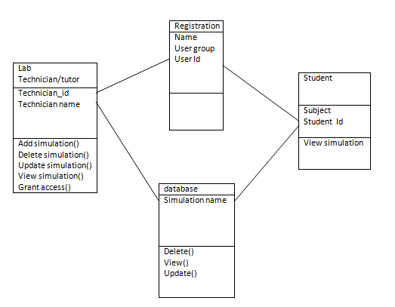

Figure 3 CLASS DIAGRAM

# 5 .3 ENTITY RELATION DIAGRAM

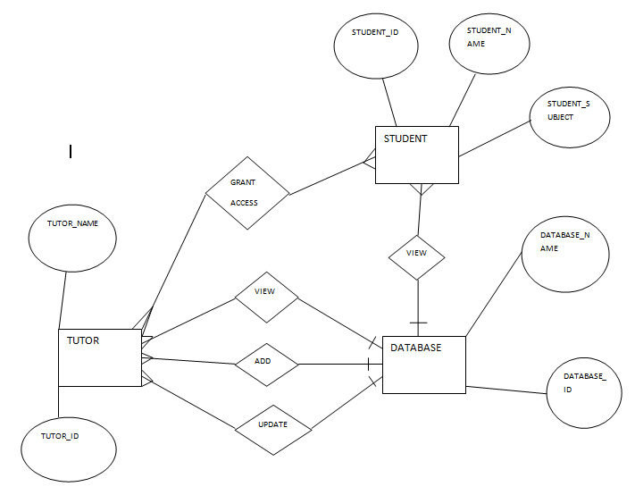

Figure 4 ENTITY RELATION DIAGRAM

# 5.4 DATA FLOW DIAGRAM

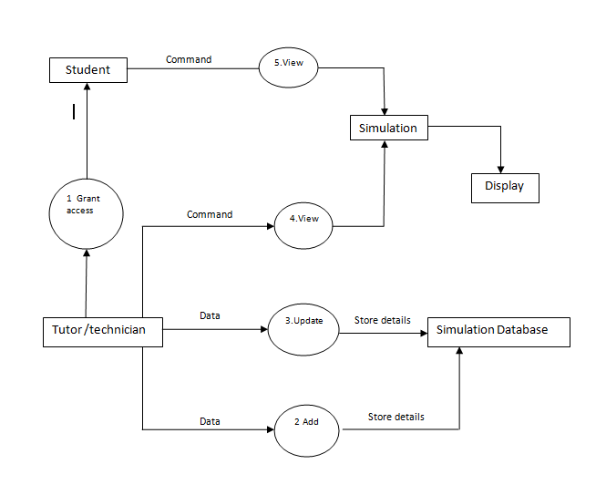

Figure 5 DATA FLOW DIAGRAM

# 5.5 DATABASE DESIGN

The database design is directly mapped from the class diagram. The path attribute for File and

Folder table is optional, because the path of a file can be calculated by the relation between parent folders.

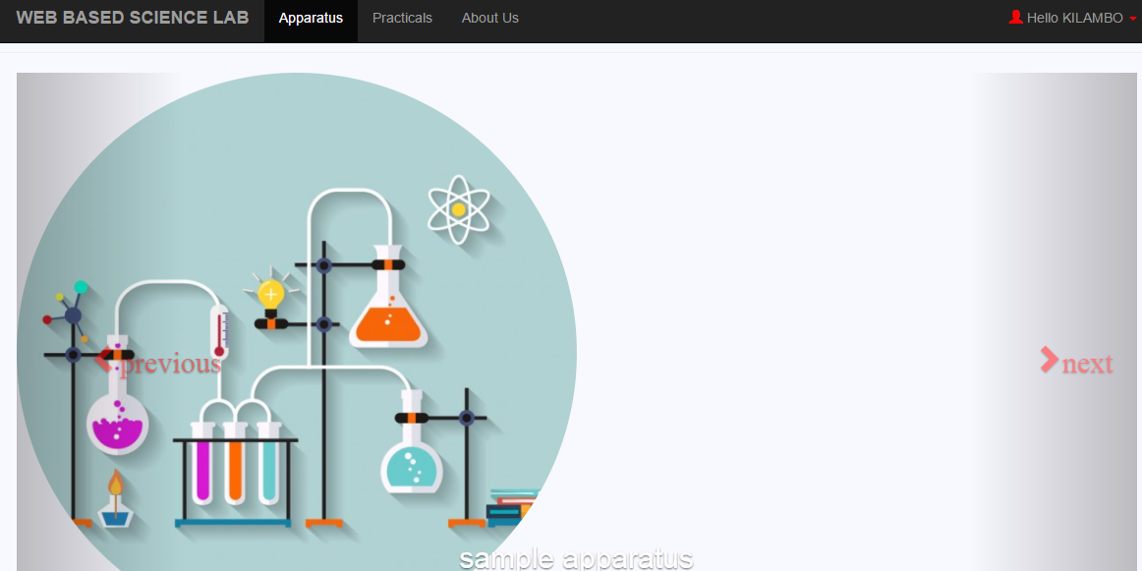

Figure 6 INPUT DESIGN

# 

Figure 7 OUTPUT DESIGNAPPENDIX

CHAPTER 6: SYSTEM IMPLEMENTATION AND TESTING.

#### 6.0: Introduction

This section guides system users about this software application, implementation and its functionalities. The system application is implemented using Windows 8 environment and the database management system used is MySQL (Oracle Corporation).

Security and accessibility to the database is done through use of passwords to access the database and user name.

#### 6.1: Implementation

Includes all components of the system that is: hardware, software and training users of the system and a parallel conversion is used for the advantage of low risks and being able to compare performance with the old one.

#### 6.2: Software life-cycle model

In this system the waterfall model will be employed. The approach will enforce proper installation, documentation is a must and you cannot proceed to another phase without approval from the management, which is easy and cheap to maintain.

#### 6.3: Testing

The aim of the system testing process is to determine all defects in our project .The program was subjected to a set of test inputs and various observations were made and based on these observations it will be decided whether the program behaves as expected or not.

This software will work as a prototype model thus testing of the product functionality is based in part on the results of executing the product in a known environment with selected inputs and testing for validation to determine whether the application as a whole satisfies the specifications or objectives will be done.

* *This will be done as follows:*
  + Testing of each component.
  + Testing integration of each component in the system.
  + Correct working in a live environment testing.
  + User acceptance testing.

##### 6.3.1: Test Scope

In the scope of the user acceptance testing will cover the following to determine if the system has met user requirements and problem that is being addressed solved.

1. Very first of prototype of the system
2. User evaluating system effectiveness as defined by use cases.
3. Administrator-facing functionality defined by use cases

##### 6.3.2: Test Strategy

For the Simulated Online Laboratory, acceptance testing will be done by the users, supervisor and administrators of the system.

User acceptance shows that other tests were good thus after users accept the simulated laboratory system shows that it’s stable and reliable. In case of any changes they will be sent to the development team and change be determined but the team together with the test team. The change will then be evaluated and determine if the change is required or not. If change is needed the bug report will be translated changed and passed on to development.

##### 6.3.3: Preconditions

Before testing will have:

1. Web based Science Laboratory System functionally specified as use cases and usage scenarios.
2. Validation test
3. Procedures of dealing with changes in the test process.
4. Acceptance testing specification.
5. Enough resources
6. An implemented test environment for the testing
7. Available standards for the acceptance testing

##### 6.3.4: Test Priorities

The testing will be done in order of priority

1. Required functions are available and working as expected
2. User-friendliness and intuitiveness of.
3. System security and guarantee user data is
4. Response times are within limit.
5. How straightforward it is to use the application in new, unpredicted ways.

##### 6.3.5: Test Techniques

The following will take place:

1. Simulated Online Laboratory System will be tested to determine the complexity of interactions by use of Usability checklists
2. Simulated Online Laboratory System will generate performance information to check against desired performance in performance statistics.

##### 6.3.6: Test Organization

The following are the roles:

1. Test manager - planning and ensuring the smooth running of the test process
2. Tester - carries out the tests according to the test plan, and then reports the results
3. Product manager - ensures that the tests are carried out successfully from a user perspective.
4. Test support - provides technical assistance, such as test environment configuration, and non-technical assistance, such as methodological support.

.

# CHAPTER 7: CONCLUSION

#### Introduction

This website provides a computerized version science laboratory which will benefit the students as well as the staff of the learning. It makes entire process online where student can perform practical. It also has a facility for student login where student can login and can see status of newly uploaded practical and also can give some suggestions. It has a facility of teacher’s login where teachers can add new students and also give necessary suggestion for improvement.

This project has got its achievements and has also encountered some limitation and there are some recommendation on the same for the future of this system in its scope. With the main objective of creating a complementary laboratory for practical subjects in learning institutions it’s also meant to make practical more interesting.

#### Achievements

* Simple user interface for any user with little computer knowledge thus easier to use.
* It will provide a simulated practical thus reducing all expenses involved in buying apparatus and laboratory accidents.
* The system will provide more on practical and allows you request or give comments on any practical and get information on apparatus used.

This will be achieved with only a click of a button.

#### Limitations

* Limited financial resources to help complete the project
* Lack of proper feedback from users when collecting data.

#### Future Scope

There is a future scope of this facility that many more features such as online lectures video tutorials can be added by teachers as well as online assignments submission facility, a feature of group chat where students can discuss various issues of engineering can be added to this project thus making it more interactive more user friendly and project which fulfills each users need in the best way possible.

#### Conclusion

Experience has become one of the most important qualification even in job market, thus, having had a good experience on laboratory apparatus provides good management practices.

The system is not to discourage students in handling laboratory equipment but give confidence through continued use of the simulated apparatus.

The system is expected to improve teaching of practical subjects and give an easier access of practical lessons through simulation practices and hopefully come to a point where in our learning institutions there’s no complains of students not being able to perform well in practical related subjects.

This system will help in managing practical part of learning and due to the technology improvement in our nation every student is expected to be well conversant with the technology used thus to cope with any future scope change of the system.

#### 

# APPENDIX A: USER MANUAL

The manual helps user in learning how to start application, use the application and close the application.

Initially log on the system using a valid email and password.

# 

Figure 8 homepage

After a successful login, one goes to the Homepage

Once on the home page one can use the navigation to choose one of several options.To display the apparatus usable in a custom laboratory, one will need to click on the apparatus tab. The next screen will display pictorial samples of the apparatus. Along with the apparatus comes a small description of its name and how it is used

Also on the home page one can click on the practical’s tab. This takes the user to a screen that has a sorted list of experiments that are available on the system.

There is also a tab on “about us” which generates a screen that gives the students and tutors details about the designers and developers of the site.

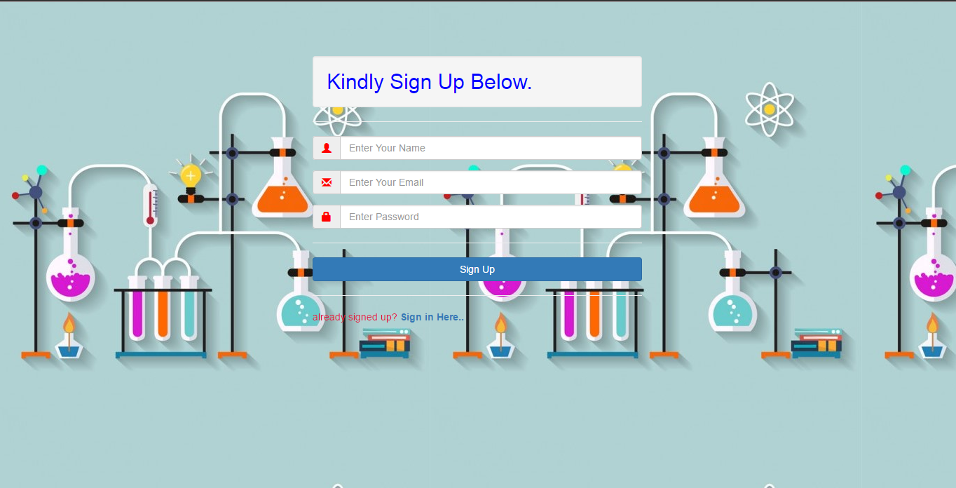

Figure 9 user registration

The user registration screen enables a new user to give his or her credentials in order for them to be able to access the system

If you are not registered please insert yout credentials and click sign up. Otherwise click the “sign in here” to access the site

hg

h

5n



Figure 10 user login

The user login screen allows registered users to access the homepage after a successful log in.

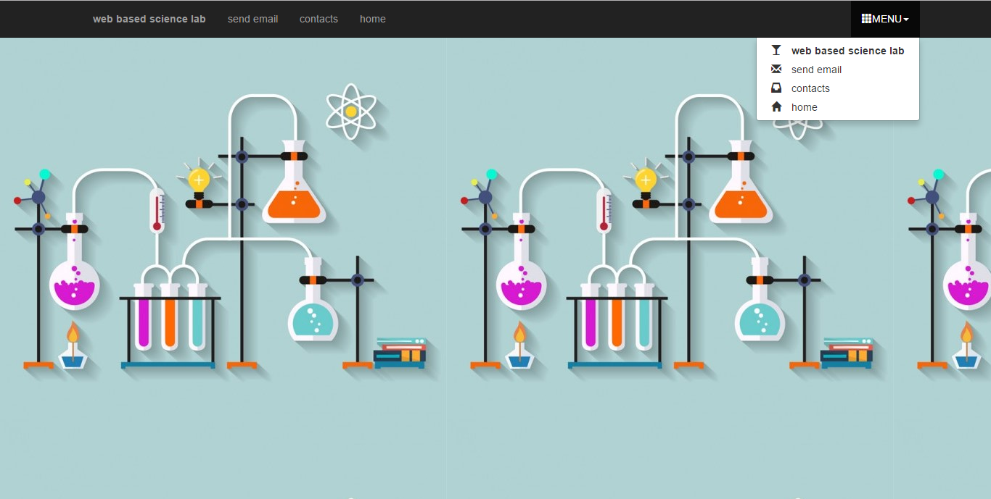

Figure 11 contacts

Click on the contacts tab to identify the channels that can be used to reach the site developers.

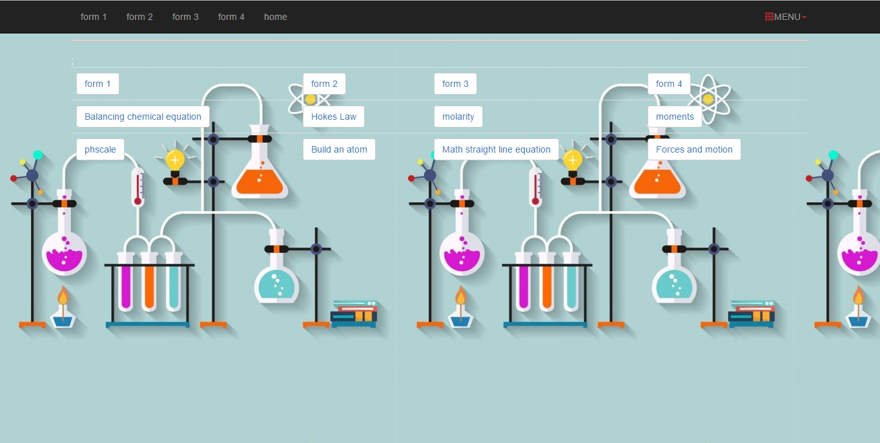

Figure 12 simulations

The practical page will enable users select one of several practical they want to perform.

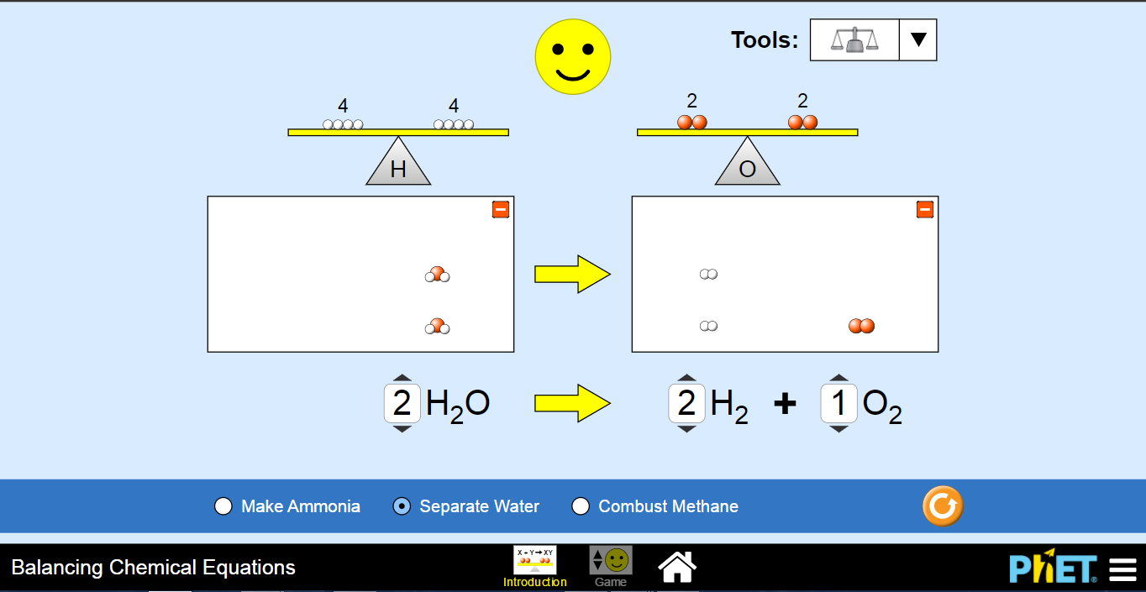

Figure 13 sample balancing chemical equation simulation

APPENDIX B

# 

# APPENDIX C

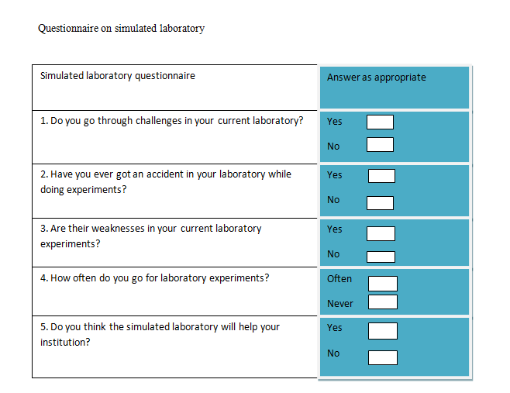

# BIBLIOGRAPHY

(n.d.).

([e.g., A. e., 2004, A. e., 1998, A. e., & 2004), C. e. (n.d.).

1991), (. (1991).

Clough. (2002). *make science come alive.* London: cockerill(Ed.).

magin. (1986). *Design and experimentation in undergraduate mechanical engineering.* Sydney,Australia: Instituition of Engineers.

Nersessian. (1991). *Conceptual change in science and science education.* Toronto,Canada: Ed.OISE Press.

Nersessian. (1991). *Hands-on experience is at the heart of science learning.* n/a: n/a.

Scanlon. (2002). *Contemporary studies to learning science.* : studies in education science.